PARALLEL SESSION ON SUSTAINABLE DEVELOPMENT PLANNING IN CONJUNCTION WITH SDGs ANNUAL MEETING CONFERENCE 2024

[1]

Abstract

1. Introduction

Please introduce your paper here. The extended abstract must be written in English, with paragraphs flowing continuously, only separated by headings, subheadings, images, and formulas. Section headings should be numbered, bolded, and set in 10-point font. Further instructions for authors follow below.

To complete your abstract, replace this placeholder text with your own paper content, ensuring you do not alter layout settings, such as font type and size, line spacing, or page margins. Before formatting your paper, write and save your content in a separate text file. Keep text and graphic files separate until after the text has been formatted and styled. You can copy your content and paste it as unformatted text (using tools like Notepad). DO NOT insert page numbers, headers, or footers. Papers that do not adhere to these guidelines may be excluded from the conference abstracts. These instructions have been formatted to demonstrate how your manuscript should be prepared, so you may use this document as a reference.

1. The Content of the Extended Abstract

The content of an extended abstract normally includes an introduction, a brief overview of the research methodology, key research findings or the main anticipated results, and a conclusion.

* 1. Manuscript length and volume limits

Abstracts are limited to three (3) A4 pages (including all figures) and 2 MB in file size. Manuscripts exceeding page limits will be truncated at the limit.

* 1. Title, author(s), affiliations and corresponding author

The title should appear in BOLD CAPITAL LETTERS of Times New Roman centered without underlining. Type the author’s name and affiliation in upper and lower case letters, centered and double-spaced below the title. For multiple organizations, use superscripted numbers to identify organizations and list the organizations after the author list. The corresponding author should be marked with an asterisk (*) and the corresponding author's email address after the affiliation (please leave one blank line before and after the corresponding author's email address).

* 1. Headings

Major captions (headings) are to be in capitals without underlining, aligned left, and bold. Subheadings should start on align left on separate lines. A blank line space should be placed before and after each heading or subheading. There should be no blank line after the title of the sections. Sub caption begins with the upper case. If you use sub-sub captions, please type it with normal plain letters. The fonts of text should be Times New Roman, 10 pt. in size, with single line spacing. At the beginning of each paragraph, please indent as on this document.

* 1. Equations

Equations are to be numbered consecutively throughout the paper. The equation number, in parentheses, should be placed flush with the right-hand margin of the column. When possible, use an equation editor. Equations and formulae should be typed and numbered consecutively with Arabic numerals in parentheses on the right-hand side of the page (if referred to explicitly in the text),

 (1)

They should also be separated from the surrounding text by one space.

* 1. Figures and tables

Hand-written lettering on figures is not acceptable. The use of color in figures and photos is recommended, but please keep in mind that the total file size never exceeds 2 MB. Figures and tables should include captions or titles in any color possible. The figures and table should be numbered consecutively.

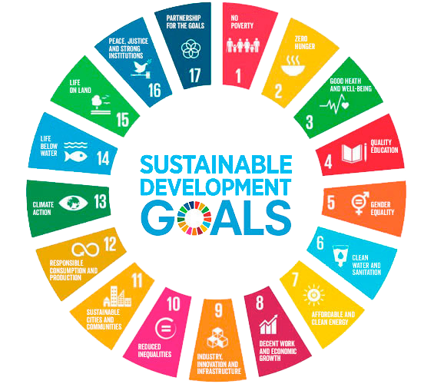

Figure 1. Sustainable Development Planning

Table 1. OTTV value in typical Indonesian buildings

**Table 1:** Probabilities of Sky Conditions in Semarang for Clear Sky

|  |  |  |  |
| --- | --- | --- | --- |
| **Month** | **ρcs(%)** | **ρps(%)** | **ρos(%)** |
| Jan | 24.38 | 1.23 | 57.24 |
| Feb | 25.12 | 2.33 | 47.57 |
| Mar | 36.21 | 1.79 | 54.12 |
| Apr | 26.32 | 2.36 | 32.03 |
| May | 31.22 | 2.54 | 43.55 |
| Jun | 32.56 | 2.14 | 53.4 |

Source: Igawa and Nakamura, 2001: 765

When possible, the table data should be centered within a single column. If there is not enough space left on the page to allow for your table, end your page and continue on the next page. The title for figures and tables should be written in an aligned style to the left, and avoid using bold, italic, and underlining. The content of the table should be written in font 8 (Times New Roman).

References

Cite the main scientific publications on which your work is based. Cite only items that you have read. Please refer to ***APA 6th Edition*** Format to write the references. Check each reference against the source (author’s name, volume, issue, year). Please use Reference Manager Applications like EndNote, Mendeley, etc. All publications cited in the text should be included as a list of references. Please ensure that every reference cited in the text is also present in the reference list (and vice versa). A blank line should be used to separate references in lists as follows:

Smith, J. A., & Doe, R. B. (2010). Understanding the complexities of climate change. Journal of Environmental Science, 15(2), 134-145.

Johnson, L. M. (2015). The impact of technology on education. Education Today, 10(4), 23-30.

1. * Corresponding author. Tel.: ; fax: .

   *E-mail address:* .